**USECASE:5 - Credit Card Fraud Detection**

**AIM**: Train a simple classifier to detect credit-card fraud on an imbalanced dataset (fraud ≈ 1%). Report accuracy, precision, recall, F1 and confusion matrix.

**ALGORITHM:**

1.Generate an imbalanced dataset that simulates fraud (1% positive class).

2. Split into train/test sets.

3. Scale features (StandardScaler).

4. Train a classifier (Logistic Regression with balanced class weights).

5. Predict on test set and compute evaluation metrics (accuracy, precision, recall, F1, confusion matrix).

6. Print results.

**CODE:**

# Run this in Google Colab

!pip -q install scikit-learn --upgrade

import numpy as np

from sklearn.datasets import make_classification

from sklearn.model_selection import train_test_split

from sklearn.preprocessing import StandardScaler

from sklearn.linear_model import LogisticRegression

from sklearn.metrics import accuracy_score, precision_score, recall_score, f1_score, confusion_matrix, classification_report

# 1) Create synthetic imbalanced dataset (simulate credit-card fraud)

X, y = make_classification(n_samples=10000, n_features=20, n_informative=6, n_redundant=2,

n_clusters_per_class=1, weights=[0.99], flip_y=0.01, class_sep=1.0, random_state=42)

# 2) Split

X_train, X_test, y_train, y_test = train_test_split(X, y, test_size=0.25, stratify=y, random_state=42)

# 3) Scale

scaler = StandardScaler()

X_train = scaler.fit_transform(X_train)

X_test = scaler.transform(X_test)

# 4) Train classifier (Logistic Regression with class_weight to handle imbalance)

clf = LogisticRegression(max_iter=1000, class_weight='balanced', solver='liblinear', random_state=42)

clf.fit(X_train, y_train)

# 5) Predict and evaluate

y_pred = clf.predict(X_test)

acc = accuracy_score(y_test, y_pred)

prec = precision_score(y_test, y_pred, zero_division=0)

rec = recall_score(y_test, y_pred, zero_division=0)

f1 = f1_score(y_test, y_pred, zero_division=0)

cm = confusion_matrix(y_test, y_pred)

print("=== Evaluation ===")

print(f"Accuracy : {acc:.4f}")

print(f"Precision: {prec:.4f}")

print(f"Recall : {rec:.4f}")

print(f"F1-score : {f1:.4f}")

print("\nConfusion Matrix (rows=true, cols=predicted):")

print(cm)

print("\nClassification Report:")

print(classification_report(y_test, y_pred, zero_division=0))

**OUTPUT:**

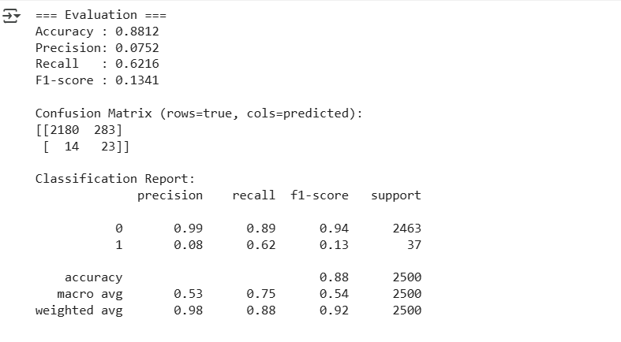

**RESULT:** Thus the above program was executed successfully and output was verified.